**SOFTWARE DESIGN DOCUMENT (SDD)**

**Smart Health Insurance Management System (SHIMS)**

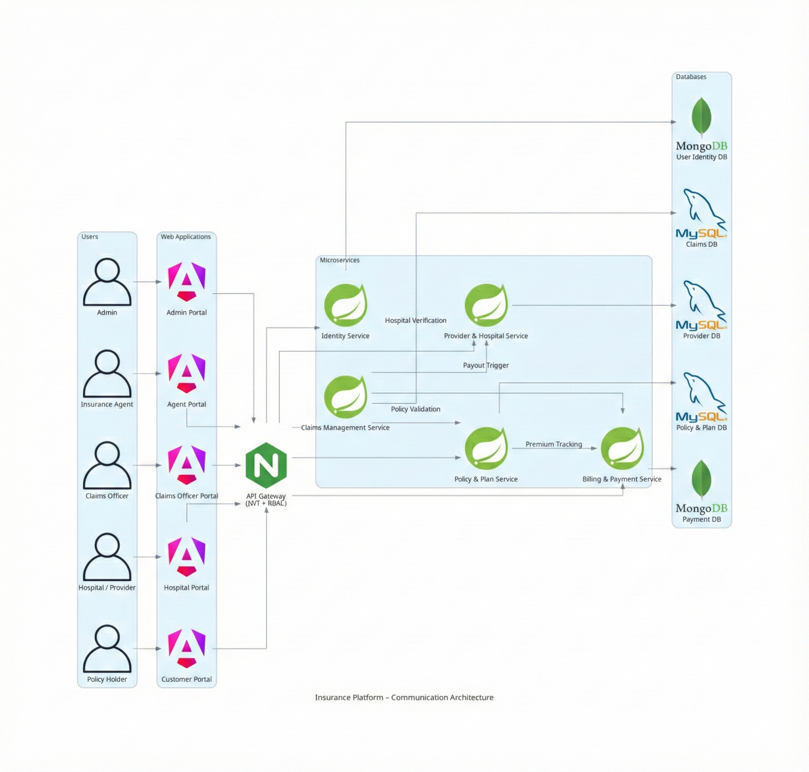 **Api Design =** <https://docs.google.com/spreadsheets/d/1Y7oRTD3BBCB2Aa30dHHE78SmYxiwv5_V2Q2DcRqtCEk/edit?usp=sharing>

**User Roles**

**Admin**

● Manage users, roles, insurance plans, hospitals, and policy rules

**Insurance Agent**

● Enroll customers and manage policy details

**Claims Officer**

● Review, approve, or reject insurance claims

**Hospital / Provider**

● Submit treatment details and insurance claims

**Policy Holder (Customer)**

● View policies, pay premiums, and track claims

**1. DOCUMENT CONTROL**

| **Item** | **Details** |
| --- | --- |
|  |  |
| Project Name | SHIMS |
| Version | 1.0 |
| Author | vishnu |
| Date | 27.12.2025 |
| Status | Initial |

**2. PURPOSE OF THE DOCUMENT**

This document describes the **system architecture, design decisions, component structure, APIs, data models, and non-functional aspects** of the Smart Order Management System.

It is intended for:

* Developers
* Reviewers
* Interview discussions
* Maintenance & enhancement planning

**3. SYSTEM OVERVIEW**

**Business Objective**

Provide a scalable, secure, and maintainable system to:

* Manage users
* Manage products
* Place and track orders
* Support growth through microservices

### Core Architecture Principles:

* **Layered Backend:** Separates concerns into Controllers (API), Services (Business Logic), and Repositories (Data Access).
* **API-Driven:** All frontend interactions happen through secured RESTful endpoints.
* **DTO Pattern:** Data Transfer Objects are used to isolate internal database entities from the API layer.
* **Global Error Handler**

**4. ARCHITECTURE OVERVIEW (HLD)**

Mobile app/ Web -> store Front WebApp -> Api gateway -> Services

**Architecture Style**

* Microservices Architecture
* REST-based communication
* Containerized deployment (docker-compose / K8s)

**Core Components**

1. Angular Frontend
2. API Gateway (optional)
3. User Service
4. Product Service
5. Order Service
6. MongoDB (per service)
7. CI/CD Pipeline (Jenkins)

**5. TECHNOLOGY STACK**

**Backend**

* Java 17
* Spring Boot
* Spring Web
* Spring Data JPA
* Spring Validation

**Frontend**

* Angular
* Angular Material
* RxJS

**Database**

* SQL DB (One per service)

**DevOps**

* Docker
* Docker Compose / K8s
* Jenkins
* SonarQube

**Testing**

* JUnit 5
* Mockito
* Spring Boot Test
* Jasmine / Karma

**6. MICROSERVICES DESIGN**

**6.1 Identity Service**

**Responsibilities**

* User registration
* Authentication
* Role management

**Database**

* user_identity DB

**6.2 Policy & Plan Service**

**Responsibilities**

* Manages Catalogs of plans
* Policy Enrollments

**Database**

* Policy_plan DB

**6.3 Claims mgmt Service**

**Responsibilities**

* Manage Claims Lifecycle
* Policy validations upholding
* Claims status

**Database**

* Claims DB

**6.4 Provider & Hospital Service**

**Responsibilities**

* Manage Network Hospitals
* Claims status

**Database**

* Provider DB

**6.5 Billing & Payment Service**

**Responsibilities**

* Tracks Payments
* Claim payouts (Lifecycle -> Requires approval Claims Officer)
* Claims status

**Database**

* Payment DB

**6.6 Notification Service**

**Responsibilities**

* Sends notification to users /admin /claims officer / providers

**Database Diagram**

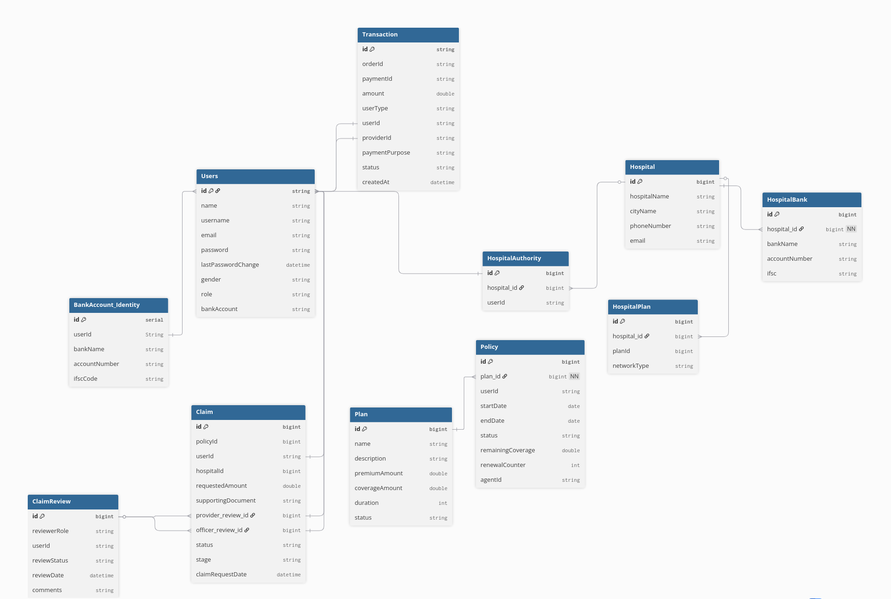

**7. DATA DESIGN (LLD)**

**User model**

{

"name": "vishnu 123",

"username": "vvishnu1231",

"email": "ante23e23eo@gmail.com",

"password": "abc12345",

"role": "USER"

"gender": "MALE"

}

**Insurance Plan model**

api = /api/plan/all

{

"name": "Silver Health Plan",

"description": "Comprehensive health insurance with high coverage",

"premiumAmount": 1500.0,

"coverageAmount": 500000.0,

"duration": 12,

"status": "ACTIVE",

"id": 2

}

**Policy (User enrollment) model**

{

"policyId": "POL9001",

"userId": "101",

"planId": "P1001",

"startDate": "2025-01-01",

"endDate": "2025-12-31",

"policyStatus": "ACTIVE",

"expiryAlertSent": false

}

**Claim model**

{

"claimId": "CLM3001",

"policyId": "POL9001",

"userId": "101",

"providerId": "HSP200",

"claimAmount": 85000,

"claimStatus": "IN_REVIEW",

"submittedDate": "2025-02-15",

"approvedAmount": 80000

}

**Hospital model**

{

"providerId": "HSP200",

"providerName": "Apollo Hospital",

"city": "Bangalore",

"contactNumber": "+91-9876543210"

}

**Payment model**

{

"paymentId": "PAY7001",

"policyId": "POL9001",

"userId": "101",

"amount": 12000,

"policyType": "PREMIUM",

"paymentStatus": "COMPLETED",

"paymentDate": "2025-01-01"

}

# DB design

## 1. Auth

Owns:

user db - user_table

Responsible:

user management and their functionalities

## 2. Policy Service

Owns:

policy db - plans_table, policy_user_table

Responsible:

policy management and their functionalities

## 3. Claims Service

Owns:

claims db - claims_table, claims_revivew (like urls of proof)

Responsible:

claims management and the process

## 4.Provider Service

Owns:

Hospital db - provider_table, provider_authority, provider_bank, provider_plan

Responsible:

Providers management and their functionalities

## 5. Payment Service

Owns:

payment db - transactions_table

Responsible:

Payment and related works

## 6. Notification Service

Responsible:

sending notification

**8. API DESIGN & VALIDATION**

* RESTful principles
* JSON request/response
* Bean Validation at DTO layer
* Service-level business rule enforcement
* Standard HTTP status codes

**Business Rules**  
  
User & Security

* User must be authenticated to access APIs
* Access is role-based
* Passwords are encrypted

Policy

* One user can have multiple policies
* Policy must be ACTIVE to use
* Policy expires after end date
* Policy renewal extends validity

Claims

* Claim must belong to a valid policy
* Claims not allowed for EXPIRED policies
* Claim follows lifecycle:  
  Submitted -> In Review -> Approved ->Paid / Rejected
* Only Claims Officer can approve/reject

Providers

* Only network hospitals can submit claims
* Providers cannot approve claims

Payments

* Premium payment required to activate policy
* Claim payout only after approval
* Payment status tracked (PENDING / COMPLETED)

**9. ERROR HANDLING STRATEGY**

**Global Exception Handling**

* Centralized using @ControllerAdvice
* Standard error response format

{

"timestamp": "2025-01-01T10:00:00",

"status": 400,

"error": "Validation Error",

"message": "Price must be greater than zero"

}

**10. SECURITY DESIGN**

* Password encryption (BCrypt)
* Role-based access control
* JWT authentication (optional enhancement)
* Secure API access

**11. NON-FUNCTIONAL REQUIREMENTS**

| **Area** | **Design Decision** |
| --- | --- |
| Scalability | Stateless services, Docker |
| Performance | Pagination, async calls |
| Availability | Independent services |
| Maintainability | POM-like layered backend |
| Security | Validation, encryption |
| Observability | Logging & monitoring |

**12. TESTING STRATEGY**



**Backend**

* Unit tests (Service layer)
* Controller tests (MockMvc)
* Minimum 90% coverage

**Frontend**

* Component tests
* Service tests

**Quality Gates**

* SonarQube enforced
* Build fails on violations

**13. CI/CD DESIGN**





**Pipeline Flow**

1. Git Commit
2. Jenkins Build
3. Unit Tests
4. SonarQube Scan
5. Quality Gate Check
6. Docker Build
7. Docker Compose Deploy

**14. DEPLOYMENT DESIGN**

* Docker image per microservice
* docker-compose for orchestration / k8s
* Environment-specific configs

**15. ASSUMPTIONS & CONSTRAINTS**

**Assumptions**

* Services communicate over REST
* mysql available
* Docker environment present

**Constraints**

* No distributed transactions
* Event-driven architecture out of scope

**16. FUTURE ENHANCEMENTS**

* Spring Cloud Gateway
* Kafka-based async communication
* Kubernetes deployment
* Centralized logging (ELK)

**17. CONCLUSION**

This design ensures:  
✔ Clean separation of concerns  
✔ Scalability & maintainability  
✔ Testability & CI/CD readiness  
✔ Interview-ready explanation

**\SEQUENCE DIAGRAMS — SMART ORDER MANAGEMENT SYSTEM**

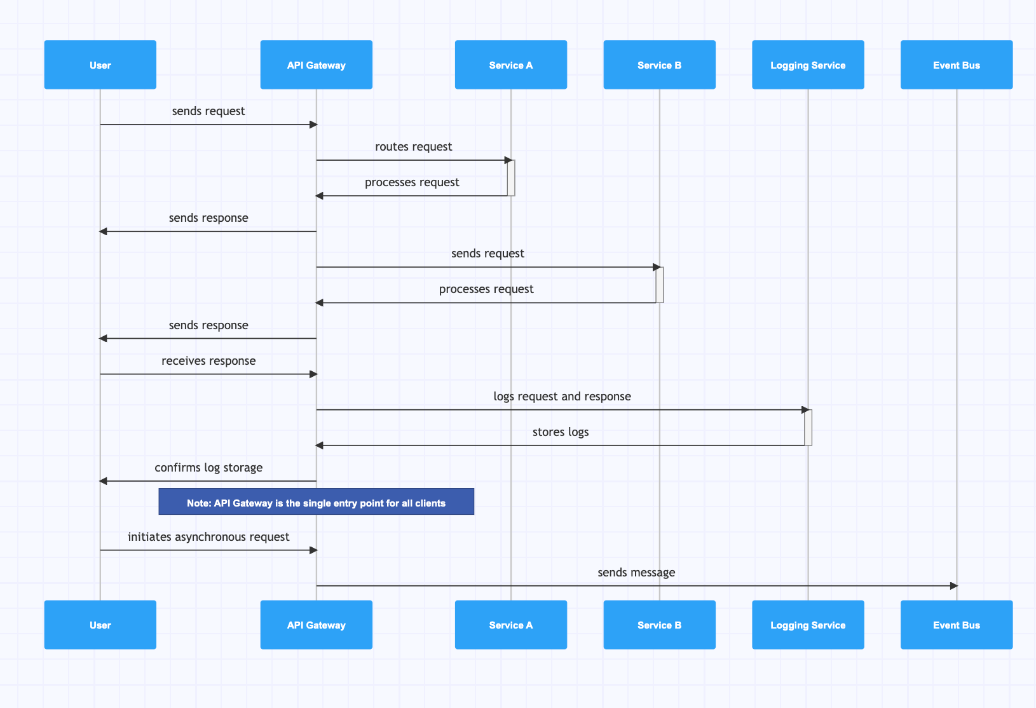

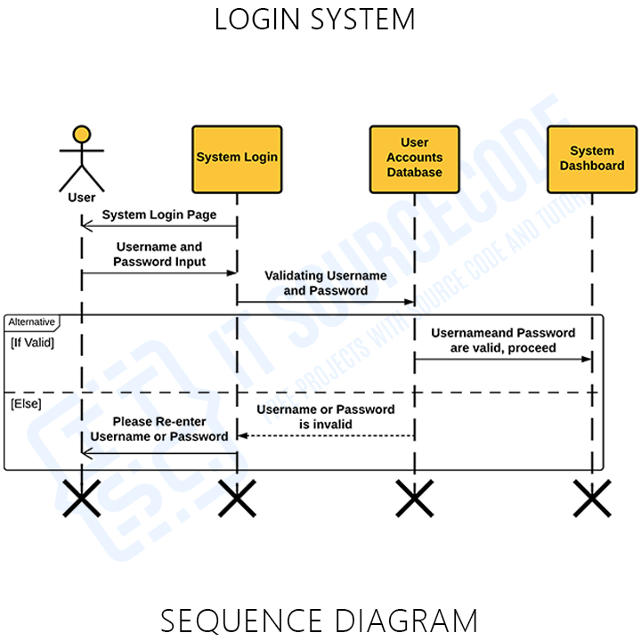

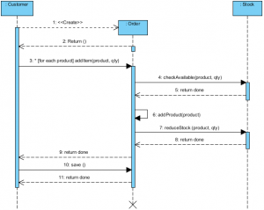

**1. User Registration — Sequence Diagram**

**Scenario**

A new user registers using the Angular UI.

**Flow**

1. User enters details in Angular UI
2. Angular sends POST /users/register to User Service
3. User Service validates request (email, password)
4. User Service checks email uniqueness in MongoDB
5. Password is encrypted
6. User is saved in MongoDB
7. Success response sent back to UI

**Participants**

* User
* Angular UI
* User Service
* MongoDB

**Key Design Points**

* Validation at API boundary
* Encryption at service layer
* No direct DB access from UI

**2. User Login — Sequence Diagram**

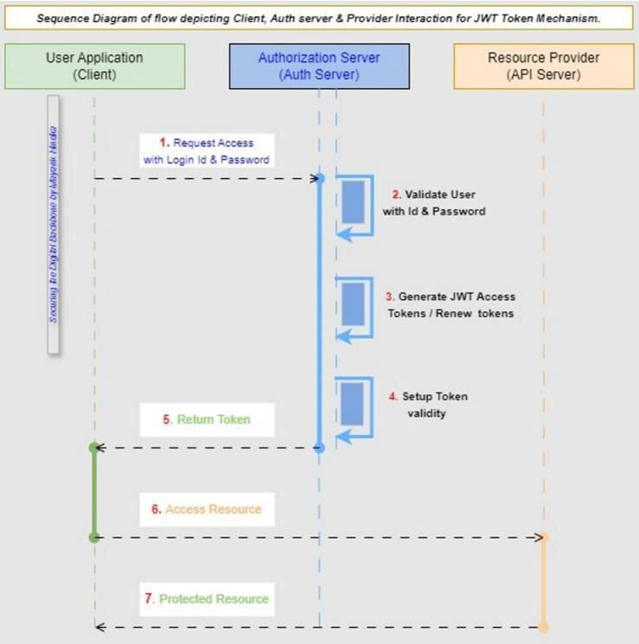

**Scenario**

Registered user logs into the system.

**Flow**

1. User submits login form
2. Angular calls POST /users/login
3. User Service fetches user from MongoDB
4. Password is verified
5. (Optional) JWT token generated
6. Response sent to Angular
7. Angular stores token and navigates user

**Participants**

* User
* Angular UI
* User Service
* MongoDB

**Failure Cases**

* Invalid credentials → 401
* Inactive user → 403

**3. Product Listing — Sequence Diagram**

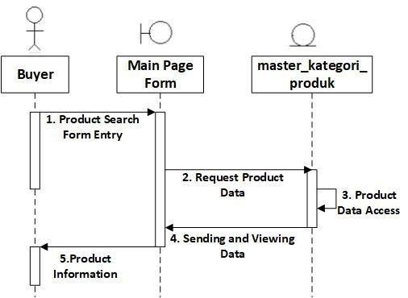

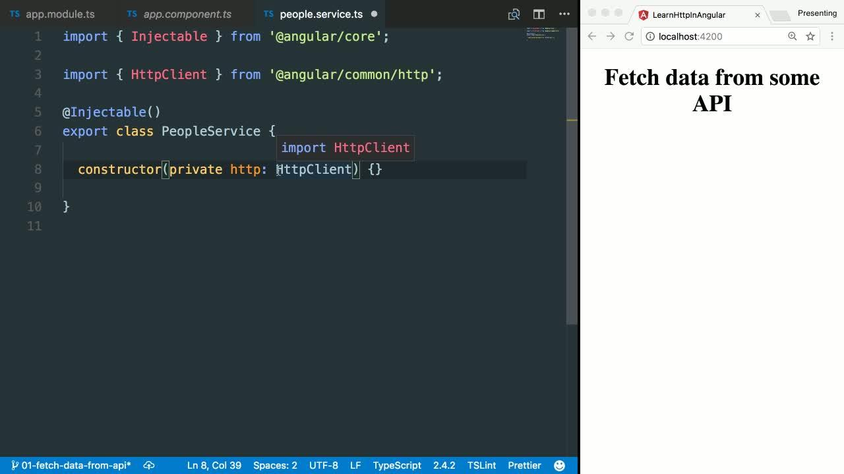

**Scenario**

User views available products.

**Flow**

1. Angular loads product page
2. GET /products sent to Product Service
3. Product Service queries MongoDB
4. Product list returned to Angular

**Participants**

* Angular UI
* Product Service
* MongoDB

**4. Order Placement — Sequence Diagram (MOST IMPORTANT)**

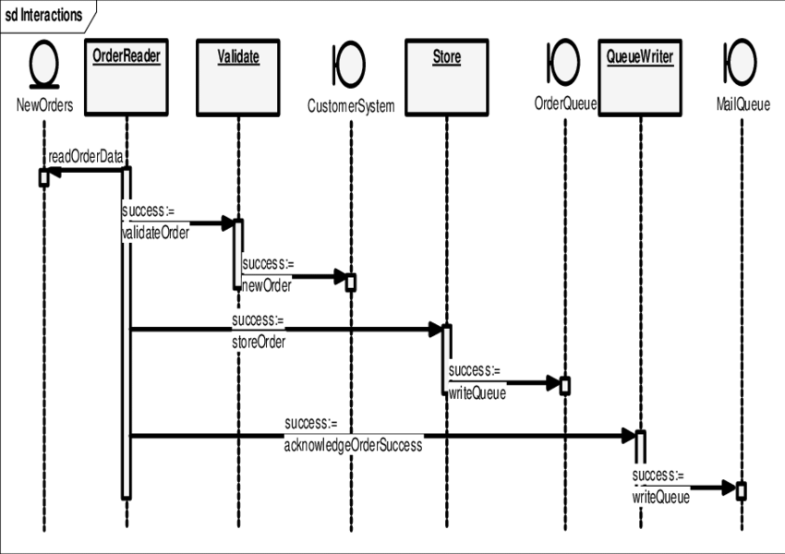

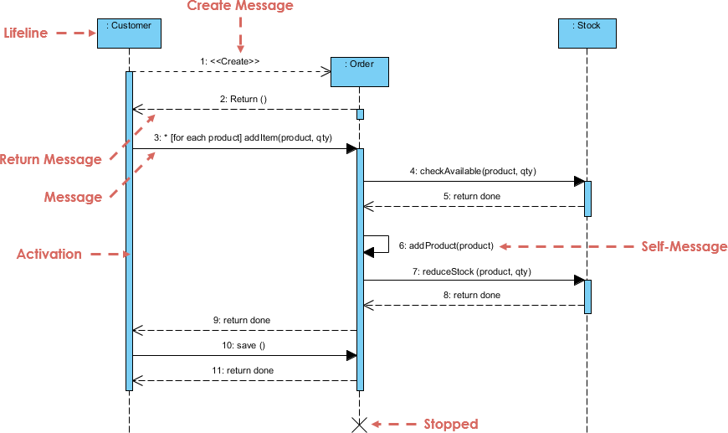

**Scenario**

User places an order for one or more products.

**Flow**

1. User clicks **Place Order** in Angular
2. Angular sends POST /orders to Order Service
3. Order Service validates request
4. Order Service calls Product Service to check stock
5. Product Service validates availability
6. Order Service creates order
7. Product Service reduces inventory
8. Order saved in MongoDB
9. Success response returned to Angular

**Participants**

* User
* Angular UI
* Order Service
* Product Service
* MongoDB

**Key Design Decisions**

* Inventory validation before order creation
* Atomic stock update logic
* Failure stops order creation

**5. Order Status Update (Admin) — Sequence Diagram**

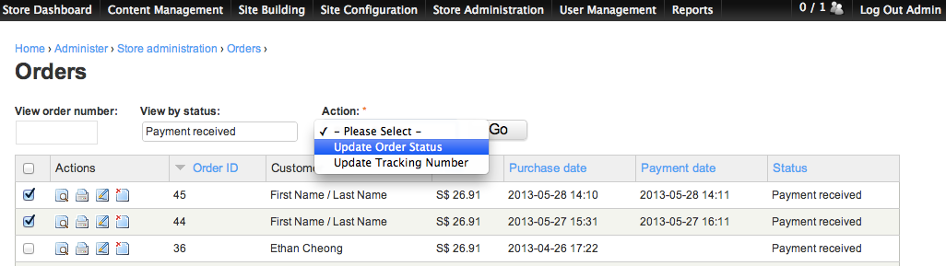

**Scenario**

Admin updates order status.

**Flow**

1. Admin sends update request from Angular
2. PUT /orders/{id}/status sent to Order Service
3. Role validation (ADMIN only)
4. Order status transition validated
5. Order updated in MongoDB
6. Updated status returned

**Valid Transitions**

* CREATED → PLACED
* PLACED → COMPLETED
* PLACED → CANCELLED

**6. CI/CD Pipeline — Sequence Diagram**





**Scenario**

Developer pushes code to Git repository.

**Flow**

1. Developer pushes code
2. Jenkins pipeline triggered
3. Jenkins runs unit tests
4. Jenkins runs SonarQube scan
5. Quality gate checked
6. Docker images built
7. Docker Compose deploys services

**Participants**

* Developer
* Git
* Jenkins
* SonarQube
* Docker

**7. Error Handling — Sequence Diagram**

**Scenario**

Invalid request sent to backend.

**Flow**

1. Angular sends invalid request
2. Controller validation fails
3. Global exception handler triggered
4. Standard error response returned

**Key Point**

* Consistent error structure across services

**HOW TO EXPLAIN IN INTERVIEWS**

“We use sequence diagrams to show runtime behavior.  
Each diagram highlights service boundaries, validation points, and data ownership, ensuring clean microservices communication.”

**----- upto here ------**

**SEQUENCE → CODE CLASS MAPPING**

**1) User Registration**

**Sequence Steps**

1. User submits registration form
2. API receives request
3. Validate input & business rules
4. Encrypt password
5. Persist user
6. Return response

**Code Mapping (User Service)**

| **Step** | **Layer** | **Class** | **Responsibility** |
| --- | --- | --- | --- |
| 1 | Angular | RegisterComponent | Collect form data |
| 2 | Angular | AuthService | POST /users/register |
| 3 | API | UserController | Request mapping |
| 4 | DTO | UserRegisterRequest | Bean validation |
| 5 | Service | UserService | Uniqueness checks |
| 6 | Security | PasswordEncoderConfig | BCrypt encryption |
| 7 | Repo | UserRepository | Save user |
| 8 | API | UserController | Return response |

**Key Methods**

* UserController.register(UserRegisterRequest)
* UserService.registerUser(...)
* UserRepository.existsByEmail(...)

**2) User Login**

**Sequence Steps**

1. Submit credentials
2. Fetch user
3. Verify password
4. Generate token (optional)
5. Return auth response

**Code Mapping**

| **Step** | **Layer** | **Class** | **Responsibility** |
| --- | --- | --- | --- |
| 1 | Angular | LoginComponent | Capture credentials |
| 2 | Angular | AuthService | POST /users/login |
| 3 | API | AuthController | Handle login |
| 4 | Repo | UserRepository | Find by email |
| 5 | Service | AuthService | Password match |
| 6 | Security | JwtTokenProvider | Create JWT |
| 7 | API | AuthController | Return token |

**Key Methods**

* AuthController.login(LoginRequest)
* AuthService.authenticate(...)

**3) Product Listing**

**Sequence Steps**

1. UI requests products
2. Fetch from DB
3. Return list

**Code Mapping (Product Service)**

| **Step** | **Layer** | **Class** | **Responsibility** |
| --- | --- | --- | --- |
| 1 | Angular | ProductListComponent | Load products |
| 2 | Angular | ProductApiService | GET /products |
| 3 | API | ProductController | Handle request |
| 4 | Service | ProductService | Business logic |
| 5 | Repo | ProductRepository | Query MongoDB |

**Key Methods**

* ProductController.getAllProducts()
* ProductService.findAll()

**4) Order Placement (Critical Flow)**

**Sequence Steps**

1. Place order
2. Validate request
3. Check stock
4. Reduce inventory
5. Create order
6. Persist & respond

**Code Mapping (Order + Product Services)**

| **Step** | **Service** | **Class** | **Responsibility** |
| --- | --- | --- | --- |
| 1 | Angular | CheckoutComponent | Submit order |
| 2 | Angular | OrderApiService | POST /orders |
| 3 | Order API | OrderController | Receive order |
| 4 | DTO | OrderRequest | Validate payload |
| 5 | Order Svc | OrderService | Orchestrate flow |
| 6 | Order Svc | ProductClient | Call Product Service |
| 7 | Product API | ProductController | Validate stock |
| 8 | Product Svc | InventoryService | Deduct quantity |
| 9 | Order Repo | OrderRepository | Save order |
| 10 | Order API | OrderController | Return result |

**Key Methods**

* OrderService.placeOrder(OrderRequest)
* ProductClient.checkAndReserveStock(...)
* InventoryService.reduceStock(...)

**5) Order Status Update (Admin)**

**Sequence Steps**

1. Admin updates status
2. Validate role
3. Validate transition
4. Update order

**Code Mapping**

| **Step** | **Layer** | **Class** | **Responsibility** |
| --- | --- | --- | --- |
| 1 | Angular | AdminOrderComponent | Update status |
| 2 | Angular | OrderApiService | PUT /orders/{id}/status |
| 3 | Security | JwtAuthFilter | Role validation |
| 4 | API | OrderController | Accept request |
| 5 | Service | OrderService | Validate transition |
| 6 | Repo | OrderRepository | Persist status |

**Key Methods**

* OrderService.updateStatus(orderId, status)
* OrderStatusValidator.isValidTransition(...)

**6) Global Validation & Error Handling**

**Sequence Steps**

1. Invalid input
2. Validation fails
3. Standard error response

**Code Mapping**

| **Step** | **Layer** | **Class** | **Responsibility** |
| --- | --- | --- | --- |
| 1 | DTO | @Valid annotations | Input validation |
| 2 | Framework | MethodArgumentNotValidException | Triggered |
| 3 | API | GlobalExceptionHandler | Build error response |

**Key Classes**

* GlobalExceptionHandler
* ApiErrorResponse

**7) CI/CD with SonarQube**

**Sequence Steps**

1. Git push
2. Build & tests
3. Sonar scan
4. Quality gate
5. Docker build
6. Deploy

**Code/Config Mapping**

| **Step** | **Tool** | **File/Class** |
| --- | --- | --- |
| 1 | Git | Repository |
| 2 | Jenkins | Jenkinsfile |
| 3 | Maven | pom.xml |
| 4 | SonarQube | sonar-project.properties |
| 5 | Docker | Dockerfile |
| 6 | Compose | docker-compose.yml |

**TRACEABILITY (WHY THIS MATTERS)**

* **Sequence step** → **Controller** → **Service** → **Repository**
* Every **business rule** is enforced **either in DTO validation or service logic**
* Easy to explain **end-to-end flow** in interviews

**How to explain succinctly**

“Each sequence diagram step maps directly to a controller endpoint, a service orchestration method, and a repository call. Validation is enforced at DTO and service layers, and failures are handled centrally.”

**CODE SKELETON — PACKAGES & CLASSES**

**1. USER SERVICE (user-service)**

user-service

└─ src/main/java/com/example/user

├─ UserServiceApplication.java

│

├─ controller

│ └─ UserController.java

│

├─ service

│ ├─ UserService.java

│ └─ UserServiceImpl.java

│

├─ repository

│ └─ UserRepository.java

│

├─ model

│ └─ User.java

│

├─ dto

│ ├─ UserRegisterRequest.java

│ ├─ LoginRequest.java

│ └─ UserResponse.java

│

├─ exception

│ ├─ UserNotFoundException.java

│ ├─ DuplicateUserException.java

│ └─ GlobalExceptionHandler.java

│

└─ config

└─ SecurityConfig.java

**Key Responsibilities**

* UserController → API layer
* UserService → Business rules
* UserRepository → MongoDB access
* SecurityConfig → Password encoding / JWT (optional)

**2. PRODUCT SERVICE (product-service)**

product-service

└─ src/main/java/com/example/product

├─ ProductServiceApplication.java

│

├─ controller

│ └─ ProductController.java

│

├─ service

│ ├─ ProductService.java

│ ├─ ProductServiceImpl.java

│ └─ InventoryService.java

│

├─ repository

│ └─ ProductRepository.java

│

├─ model

│ └─ Product.java

│

├─ dto

│ ├─ ProductRequest.java

│ └─ ProductResponse.java

│

└─ exception

├─ ProductNotFoundException.java

└─ GlobalExceptionHandler.java

**Key Responsibilities**

* InventoryService → Stock validation & update
* ProductServiceImpl → Core business logic

**3. ORDER SERVICE (order-service)**

order-service

└─ src/main/java/com/example/order

├─ OrderServiceApplication.java

│

├─ controller

│ └─ OrderController.java

│

├─ service

│ ├─ OrderService.java

│ ├─ OrderServiceImpl.java

│ └─ OrderStatusValidator.java

│

├─ client

│ ├─ ProductClient.java

│ └─ UserClient.java

│

├─ repository

│ └─ OrderRepository.java

│

├─ model

│ ├─ Order.java

│ └─ OrderItem.java

│

├─ dto

│ ├─ OrderRequest.java

│ ├─ OrderItemRequest.java

│ └─ OrderResponse.java

│

└─ exception

├─ OrderNotFoundException.java

└─ GlobalExceptionHandler.java

**Key Responsibilities**

* ProductClient → Calls Product Service
* OrderStatusValidator → Valid status transitions
* OrderServiceImpl → Orchestrates order flow

**4. COMMON / SHARED CONCEPTS (Optional)**

common

└─ src/main/java/com/example/common

├─ exception

│ └─ ApiErrorResponse.java

│

├─ util

│ └─ Constants.java

│

└─ config

└─ SwaggerConfig.java

**5. ANGULAR FRONTEND (angular-ui)**

angular-ui

└─ src/app

├─ core

│ ├─ services

│ │ ├─ auth.service.ts

│ │ ├─ product.service.ts

│ │ └─ order.service.ts

│ │

│ └─ guards

│ └─ auth.guard.ts

│

├─ modules

│ ├─ auth

│ │ ├─ login.component.ts

│ │ └─ register.component.ts

│ │

│ ├─ product

│ │ └─ product-list.component.ts

│ │

│ └─ order

│ ├─ checkout.component.ts

│ └─ order-history.component.ts

│

├─ shared

│ └─ models

│ ├─ user.model.ts

│ ├─ product.model.ts

│ └─ order.model.ts

│

└─ app.module.ts

**6. TEST STRUCTURE (IMPORTANT)**

src/test/java

└─ com/example

├─ controller

│ └─ UserControllerTest.java

├─ service

│ ├─ UserServiceTest.java

│ └─ OrderServiceTest.java

└─ repository

└─ ProductRepositoryTest.java

**7. DEVOPS & CI/CD FILES**

capstone-project

├─ Jenkinsfile

├─ docker-compose.yml

├─ user-service/Dockerfile

├─ product-service/Dockerfile

├─ order-service/Dockerfile

├─ angular-ui/Dockerfile

└─ README.md

**HOW TO EXPLAIN THIS IN INTERVIEWS**

“Each microservice follows a layered architecture: Controller → Service → Repository.  
Clients handle inter-service communication.  
DTOs isolate API contracts.  
Business rules live in the service layer.  
This makes the system scalable, testable, and maintainable.”

**STARTER REPO**





**1. REPOSITORY STRUCTURE (ROOT)**

smart-order-management/

│

├─ user-service/

├─ product-service/

├─ order-service/

├─ angular-ui/

│

├─ common/

│

├─ docker-compose.yml

├─ Jenkinsfile

├─ .gitignore

├─ README.md

You can create this repo **as-is** in GitHub.

**2. USER SERVICE (Spring Boot)**

user-service/

├─ src/main/java/com/example/user

│ ├─ UserServiceApplication.java

│ │

│ ├─ controller

│ │ └─ UserController.java

│ │

│ ├─ service

│ │ ├─ UserService.java

│ │ └─ UserServiceImpl.java

│ │

│ ├─ repository

│ │ └─ UserRepository.java

│ │

│ ├─ model

│ │ └─ User.java

│ │

│ ├─ dto

│ │ ├─ UserRegisterRequest.java

│ │ ├─ LoginRequest.java

│ │ └─ UserResponse.java

│ │

│ ├─ exception

│ │ ├─ DuplicateUserException.java

│ │ └─ GlobalExceptionHandler.java

│ │

│ └─ config

│ └─ SecurityConfig.java

│

├─ src/test/java/com/example/user

│ ├─ controller/UserControllerTest.java

│ └─ service/UserServiceTest.java

│

├─ Dockerfile

├─ pom.xml

└─ application.yml

**3. PRODUCT SERVICE**

product-service/

├─ src/main/java/com/example/product

│ ├─ ProductServiceApplication.java

│ ├─ controller/ProductController.java

│ ├─ service

│ │ ├─ ProductService.java

│ │ ├─ ProductServiceImpl.java

│ │ └─ InventoryService.java

│ ├─ repository/ProductRepository.java

│ ├─ model/Product.java

│ ├─ dto/ProductRequest.java

│ └─ exception/GlobalExceptionHandler.java

│

├─ src/test/java/com/example/product

│ └─ service/ProductServiceTest.java

│

├─ Dockerfile

├─ pom.xml

└─ application.yml

**4. ORDER SERVICE**

order-service/

├─ src/main/java/com/example/order

│ ├─ OrderServiceApplication.java

│ ├─ controller/OrderController.java

│ ├─ service

│ │ ├─ OrderService.java

│ │ ├─ OrderServiceImpl.java

│ │ └─ OrderStatusValidator.java

│ ├─ client

│ │ ├─ ProductClient.java

│ │ └─ UserClient.java

│ ├─ repository/OrderRepository.java

│ ├─ model

│ │ ├─ Order.java

│ │ └─ OrderItem.java

│ └─ dto/OrderRequest.java

│

├─ src/test/java/com/example/order

│ └─ service/OrderServiceTest.java

│

├─ Dockerfile

├─ pom.xml

└─ application.yml

**5. ANGULAR FRONTEND**

angular-ui/

├─ src/app

│ ├─ core

│ │ ├─ services

│ │ │ ├─ auth.service.ts

│ │ │ ├─ product.service.ts

│ │ │ └─ order.service.ts

│ │ └─ guards/auth.guard.ts

│ │

│ ├─ modules

│ │ ├─ auth

│ │ │ ├─ login.component.ts

│ │ │ └─ register.component.ts

│ │ ├─ product/product-list.component.ts

│ │ └─ order/checkout.component.ts

│ │

│ └─ shared/models

│ ├─ user.model.ts

│ ├─ product.model.ts

│ └─ order.model.ts

│

├─ Dockerfile

└─ angular.json

**6. DOCKER COMPOSE**

version: '3.8'

services:

mongodb:

image: mongo

ports:

- "27017:27017"

user-service:

build: ./user-service

ports:

- "8081:8081"

depends_on:

- mongodb

product-service:

build: ./product-service

ports:

- "8082:8082"

depends_on:

- mongodb

order-service:

build: ./order-service

ports:

- "8083:8083"

depends_on:

- mongodb

angular-ui:

build: ./angular-ui

ports:

- "4200:80"

**7. JENKINSFILE (CI/CD + SONARQUBE)**

pipeline {

agent any

stages {

stage('Checkout') {

steps { git 'https://github.com/your-org/smart-order-management.git' }

}

stage('Build & Test') {

steps { sh 'mvn clean test' }

}

stage('SonarQube Scan') {

steps {

withSonarQubeEnv('SonarQube') {

sh 'mvn sonar:sonar'

}

}

}

stage('Quality Gate') {

steps {

timeout(time: 2, unit: 'MINUTES') {

waitForQualityGate abortPipeline: true

}

}

}

stage('Docker Build & Deploy') {

steps {

sh 'docker-compose up -d --build'

}

}

}

}

**8. README.md (MINIMAL TEMPLATE)**

# Smart Order Management System

## Tech Stack

- Spring Boot Microservices

- Angular

- MongoDB

- Docker

- Jenkins + SonarQube

## Run Locally

docker-compose up -d

## Services

- User Service: 8081

- Product Service: 8082

- Order Service: 8083

- UI: http://localhost:4200

Map **design → code structure**

Tell me what you want to generate next.